Lab 4

Doubly Linked List

Objective:
The objective of this lab is to implement Doubly Linked List.

Introduction:
A doubly linked list is a linked list in which every node has a next pointer and a back pointer. In other words, every node contains the address of the next node ( last node points to null as next node), and every node contains the address of the previous node (first node points to null as the previous node).

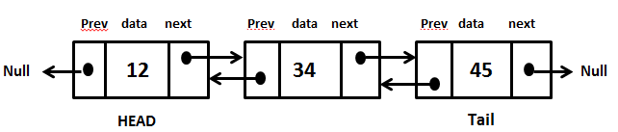

Doubly Linked List
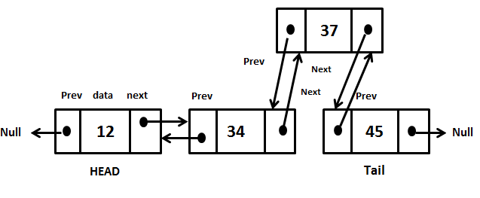

Insertion

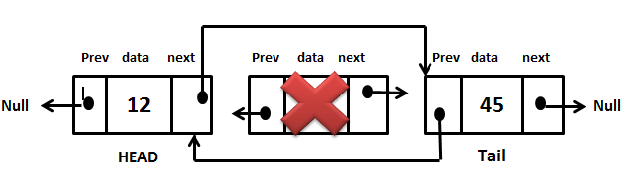
Deletion

Exercise 1: Implement a doubly linked list.
Implement all the methods given in the following class definition for doubly linked list. Run the main program which follows, demonstrating the use of the functions of the doubly linked list.
#ifndef DLIST_H
#define DLIST_H

template<class T>
struct Node
{
T data;
Node *next ;
Node *previous ;
// constructor
Node(T pdata);
// Destructor
~Node();
};

template<class T>
class DList
{
private:
Node<T> *first ;
public:
DList();

//Inserts the node pNew after the node pBefore
// if the list is empty, it makes pNew the first node of the list
void Insert(Node<T>* pBefore, Node<T>* pNew);
//Deletes the node pToBeDeleted
void Delete(Node<T>* pToBeDeleted);
//prints the contents of the list
void printList();

void swap(Node<T>* N1, Node<T>* N2);
//swaps node1 and node2

};
#endif

int main()
{
Node<int> *a, *b, *c, *d, *e,*f;

a = new Node<int>(200);
b = new Node<int>(30);
c = new Node<int>(40);
d = new Node<int>(45);
e = new Node<int>(450);

DList<int> *list;

list = new DList<int>();

list->Insert(0 , a);
list->Insert(a , b);
list->Insert(b , c);
list->Insert(a , d);
list->Insert(b, e);
list->printList();

list->Delete(c);
cout<<"\nAfter deleting first node"<<endl;
list->printList();

list->swap(b,d);

cout<<"\nAfter calling function"<<endl;
list->printList();

return 0;
}

POST LAB:
Implement all the functionalities of doubly circular linked list as given below and write a main function demonstrating their use.

template<class T>
class DoubleCList
{
private:
Node<T> *first ;
public:
DoubleCList();

//Inserts the node pNew after the node pBefore
// if the list is empty, it makes pNew the first node of the list
void Insert(Node<T>* pBefore, Node<T>* pNew);
//Deletes the node pToBeDeleted
void Delete(Node<T>* pToBeDeleted);
//prints the contents of the list
void printList();

void printReverse();
//write a recursive function to print the list in //reverse order

};

Lab 5

